| Photo displaying partial image of two pie charts on a canvas-textured page  CAPSTONE PROJECT  SPORTS ANALYSIS |
| --- |
| **OLYMPIC SPORTS** |
| |  |  |  | | --- | --- | --- | |

**OBJECTIVE**

The objective of this Olympic sports analysis is to conduct an in-depth examination of the historical and contemporary dynamics shaping the Olympic Games, with a focus on key aspects such as athlete performance, participation trends, and medal distributions. This includes analyzing the evolution of sports disciplines, the inclusion of diverse events, and the progression toward gender equity. A critical component is assessing the socio-economic, technological, and geopolitical factors that influence athlete development and national success in the Games.

The analysis seeks to identify patterns in participation growth across regions and demographic groups, shedding light on how global accessibility to sports and training facilities impacts competitive parity. It also explores how innovations in training, nutrition, and equipment have driven performance improvements over time. By delving into medal trends and success factors, the study aims to reveal how investment in sports infrastructure and strategic planning translates into competitive advantage for nations.

Furthermore, the analysis examines the cultural and generational shifts that have led to the inclusion of new sports, highlighting the adaptability of the Games to evolving societal preferences. Through this exploration, the goal is to provide comprehensive insights that can guide stakeholders—including athletes, coaches, policymakers, and sports organizations—in fostering inclusivity, sustainability, and excellence in future Olympic competitions.

**SIGNIFICANCE**

The significance of this Olympic sports analysis lies in its ability to provide a deeper understanding of the multifaceted dynamics of the Games, which serve as a global stage for athletic excellence, cultural exchange, and international unity. The Olympics are not only a showcase of individual and team achievements but also a reflection of broader societal trends, including advancements in technology, shifts in global power dynamics, and the evolving values of inclusivity and diversity.

By analyzing historical data and contemporary trends, this study highlights the factors that contribute to success in the Olympics, such as access to training resources, national sports policies, and socio-economic conditions. It provides insights into how countries can enhance their sports programs, promote equitable opportunities for athletes of all genders, and invest strategically in sports development to achieve greater representation and success on the global stage.

This analysis also underscores the importance of innovation in sports science, equipment design, and training methodologies, revealing how these advancements have revolutionized athletic performance. By identifying key patterns and success factors, the study empowers stakeholders to address challenges, such as disparities in access to resources, and encourages the development of policies that make competitive sports more inclusive and accessible.

Moreover, the exploration of the inclusion of new sports and evolving audience preferences emphasizes the adaptability of the Olympics in staying relevant to a diverse and changing world. These findings can guide organizers and governing bodies in shaping future Games that resonate with modern audiences while upholding the core Olympic values of friendship, respect, and excellence.

Ultimately, this analysis contributes to a broader understanding of how the Olympics impact society beyond the arena, fostering global connections, inspiring new generations of athletes, and promoting unity through shared celebration of human potential.

**DATA DICTIONARY**

**SPORTS**

**This table contains a comprehensive list of all sports featured in the Olympics, covering both the summer and winter editions.**

**EVENTS**

**The Event table offers detailed information about the various events held within each sport. And event conclude the Men’s as well as women’s Event.**

**CITY**

**This table provides an extensive list of cities from around the world that have hosted or participated in the Olympic Games over the years.**

**GAMES**

**The Games table includes essential details such as the year in which the Games were held, as well as distinguishing between Summer and Winter Olympics.**

**GAMES CITY**

**This joining table Games and City tables, capturing instances where the Olympic Games were jointly hosted by multiple cities.**

**NOC REGION**

**This table consists of NOC codes, representing National Olympic Committees, and their corresponding countries also show the participation of the country.**

**PERSON**

**The Person table records information about individuals who have competed in the Olympics such as name, weight, height, id.**

**MEDAL**

**A table listing the different types of medals awarded at the Olympics, including Gold, Silver, Bronze, and N/A (indicating no medal).**

**COMPETITOR EVENT**

**This table represents providing crucial details about the combination of competitors, the events they participated in, and the medals they received.**

**GAMES COMPETITOR**

**This table serves as a joining table Olympic Games and showcasing the participants.**

**PERSON REGION**

**This joining table individuals and the countries they represented while competing in the Olympics.**

**MECE BREAKDOWN**

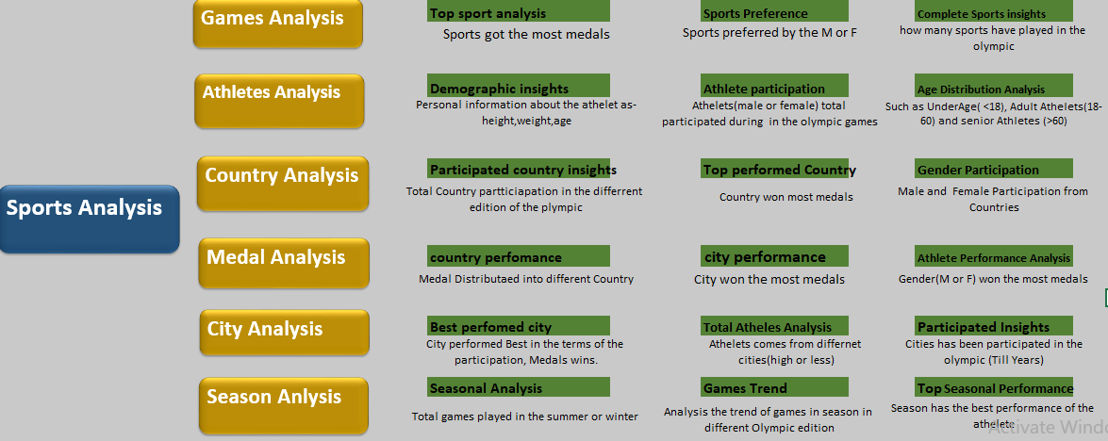

**ER DIAGRAM**

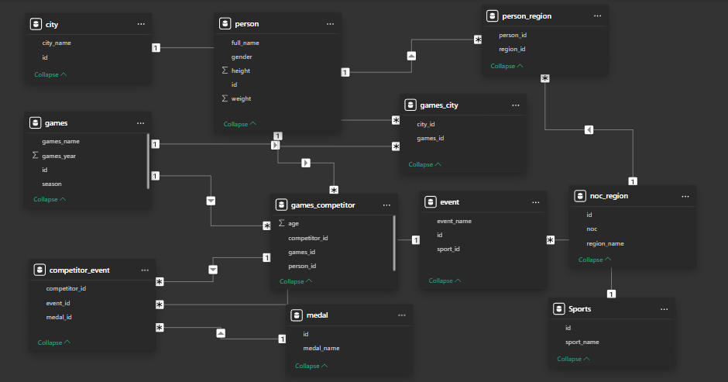

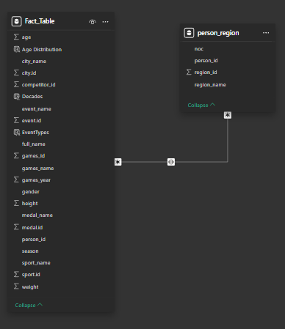

**STEPS TO CONNECT DATA**

### 1. Data Handling in Excel

1. **Download Dataset**:
   * Obtain the dataset and save it as an Excel file.
2. **Perform EDA (Exploratory Data Analysis)**:
   * Clean the dataset (remove duplicates, handle missing values, etc.).
   * Analyze the data (use formulas, pivot tables, and charts to understand trends and outliers).
   * Create at least one meaningful visualization, such as a bar chart or line graph.
3. **Conclusion**:
   * Based on the EDA and visualization, derive insights or conclusions.

### 2. SQL Data Analysis

1. **Import Data into SQL**:
   * Load the dataset into an SQL database.
2. **Write Queries**:
   * Write SQL queries to answer specific questions or extract key insights.
   * Examples: Count of categories, trends over time, etc.
3. **Export Results to Excel**:
   * Export the query results into Excel.
   * Create a relevant visualization based on the results (e.g., bar chart, pie chart).

### 3. Power BI Dashboard

1. **Define Questions**:
   * Determine the key questions or metrics to be answered/displayed using Power BI.
2. **Create Dashboard**:
   * Import the dataset into Power BI.
   * Build interactive visuals (charts, maps, slicers, etc.) with navigational buttons for seamless exploration.

### 

### 4. Presentation Creation

1. **First PPT (Overview of Visuals)**:
   * Prepare a presentation summarizing the project.
   * Include all major visuals and highlight key insights.
2. **Second PPT (Detailed Solutions)**:
   * Create a slide deck with a step-by-step explanation of each solution.
   * Include the visuals created in Excel, SQL, and Power BI.
3. **Recording**:
   * Record a walkthrough of the presentations, explaining the visuals, insights, and process.

### 

### 

### 5. Final Word Document

1. **Compilation**:
   * Consolidate all content into a Word document.
   * Include the following sections:
     + Introduction
     + EDA in Excel (with visuals and conclusions)
     + SQL query results and visuals
     + Power BI dashboard details
     + Conclusions and insights from the project
   * Add screenshots of visuals, queries, and dashboards for better clarity.
2. **Formatting**:
   * Ensure proper formatting with headings, subheadings, and page numbers

**POWER BI**

**PROBLEM STATEMENT**

**SPORT ANALYSIS**

* **EVENTS ANALYSIS**
* **GAMES ANALYSIS**
* **MEDAL ANALYSIS**
* **ATHELETS ANALYSIS**
* **REGION ANALYSIS**
* **SEASON ANALYSIS**

**EVENTS ANALYSIS**

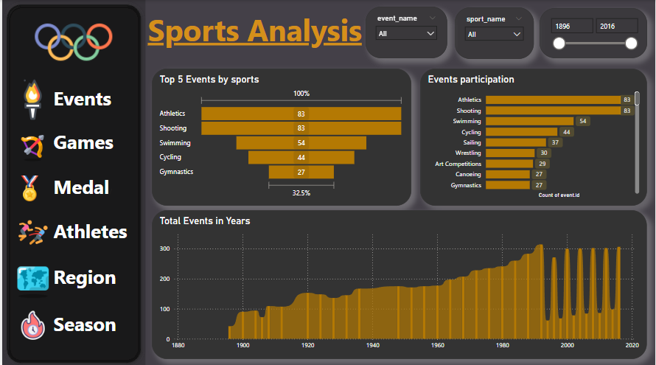

**How has the number of events changed over time?**

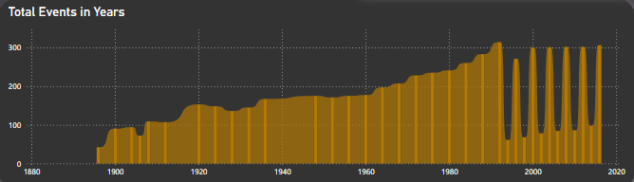

**CONCLUSION**

**Events have increased with time duration.**

**-1st Olympic games have total 42 events**

**-2016 Olympic game has 306 events.**

**Which sports have the highest number of events in the Olympics?**

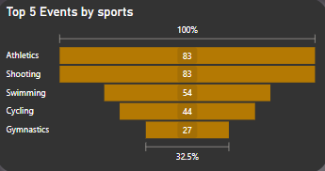 **CONCLUSION**

**These are Top 5 sports in respect of having the highest no of the events in the Olympic games, we can also consider that the participation is also high in these sports.**

**How many events are there in each sport?**

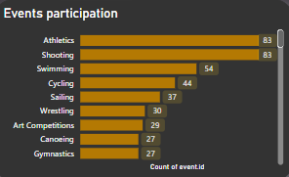

**CONCLUSION**

**Total sports types are 66.**

**Top 3 sports are Athletics, Gymnastics and Swimming, and these sports participation no in events is more than other event participation sports.**

**GAMES ANALYSIS**

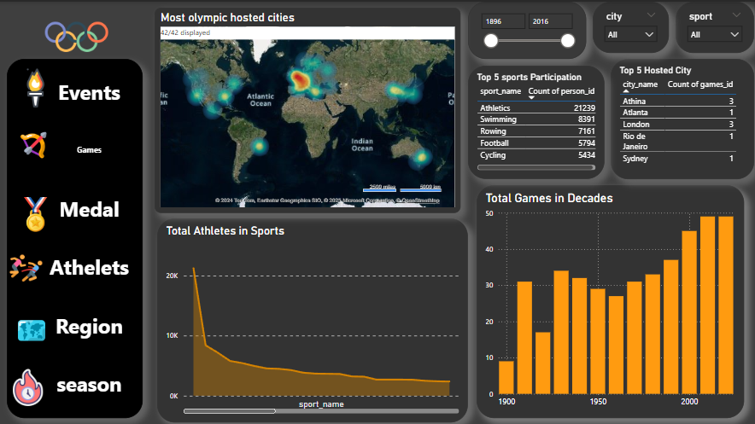

**Which cities have hosted the most Olympic Games?**

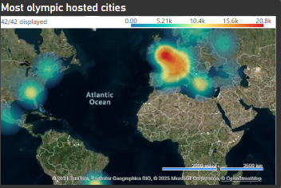

**CONCLUSION**

**These following cities have hosted the most Olympic games:**

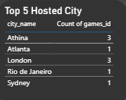

**How has the participation in each sport evolved over time?**

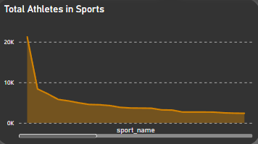

**CONCLUSION**

**These following sports participation the most Olympic games:**

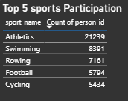

**What is the distribution of games across different decades?**

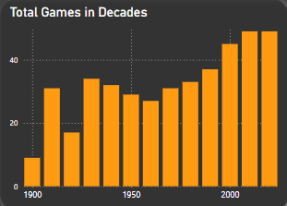

**CONCLUSION**

**We have seen change in the total games at 1900 to 2020 decade.**

* **At 1900, there are only 9 games played in Olympics.**

**- But now 2020 decade we have total 49 games.**

**Medal Analysis**

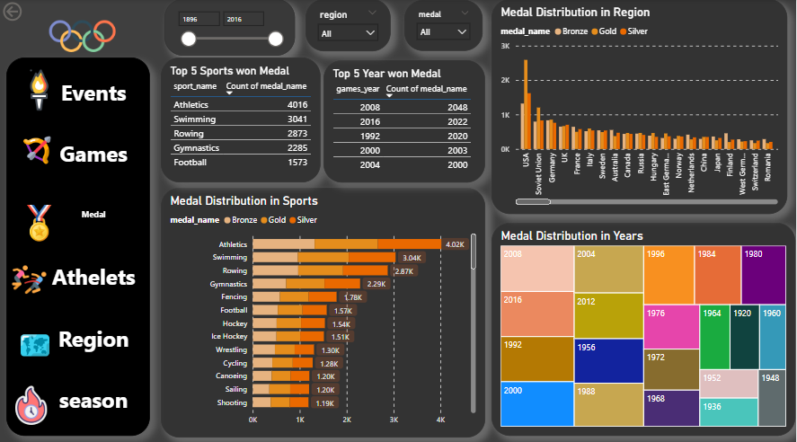

**How does the medal distribution vary across different sports?**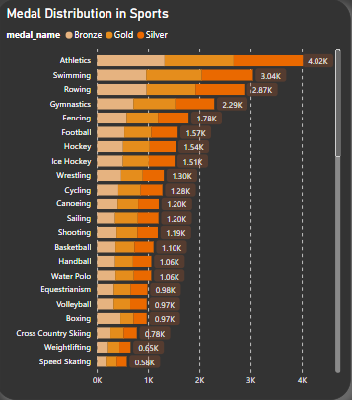

**CONCLUSION**

**Medal distribution is vary in different sports, we have top 5 sports won most medals:**

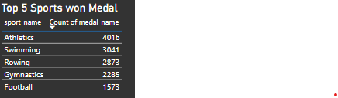

**What is the distribution of medals among different regions?**

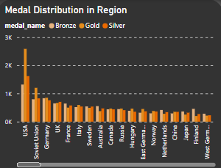**CONCLUSION**

**Top 5 Regions are:**

**-USA, Soviet Union, Germany, UK, France**

**-There participation in Olympic is also high**

**How many medals have been awarded in each Olympics?**

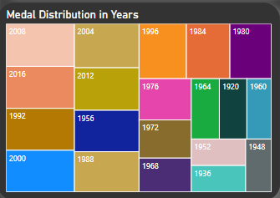

**CONCLUSION**

**These Following Years have the highest no of medals, where 2008 is the year won the most medals.**

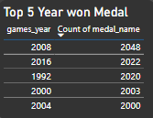

**ATHLETES ANALYSIS**

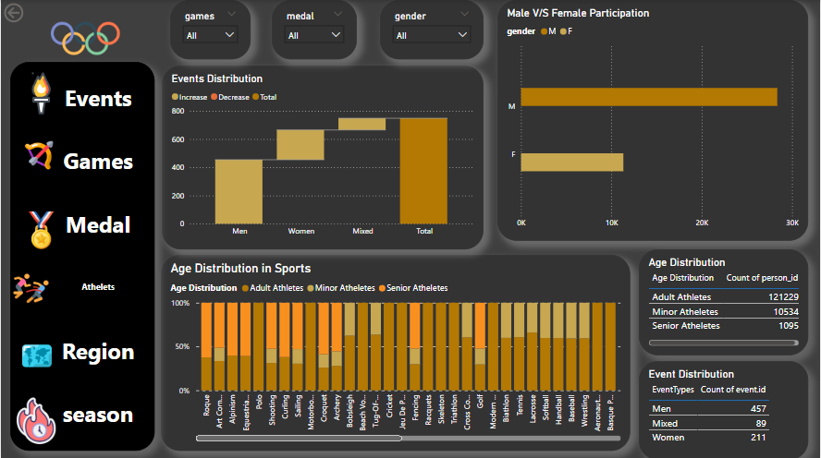

**What is the distribution of events by gender (Men, Women, Mixed)?**

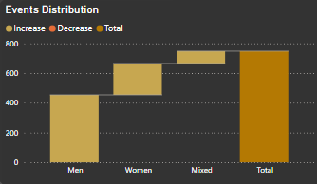

**CONCLUSION**

**Total Men Events have the highest no of events.**

**Women event is less than 50% of men Events.**

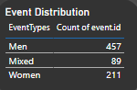

**What is the distribution of participants by gender?**

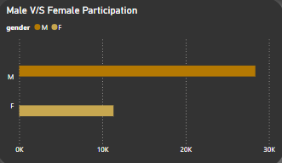

**CONCLUSION**

**Male Participation is more than 50% of female Participation in the Olympic G**

**How does the age distribution of participants vary across different games?**

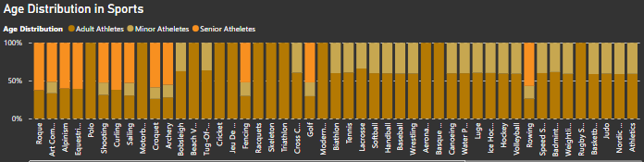

**CONCLUSION**

* **Adult Athletes is more than 90% of the total athletes participate in the Olympic Games.**
* **Minor Athletes is total 7%.**
* **Senior are less than 3%.**
* **Assumption- Minor Less than 19**
* **Adult 19-50 Senior more than 50**

**Region Analysis**

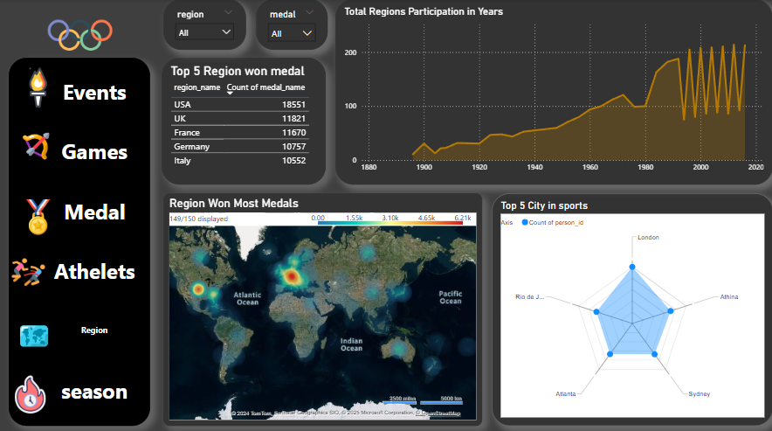**Which countries have the highest number of gold medals?**

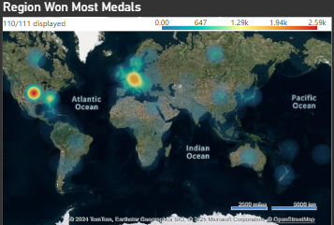

**CONCLUSION**

**These are top 5 regions won Most Gold Medals in the Olympics:**

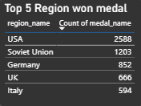

**How many regions or NOCs participate in each Olympic Games?**

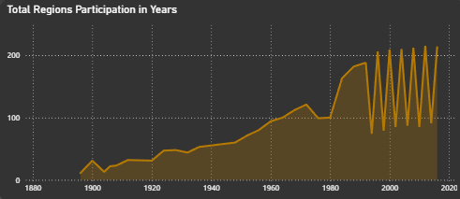

**CONCLUSION**

**Total regions are 231 which participated in Olympics.**

**In 1896 we have total participated regions are 11.**

**-In 1896 we have total participated regions are 213.**

**Which shows participation increased with the years**

**Which city have the highest number of participants in the Olympics?**

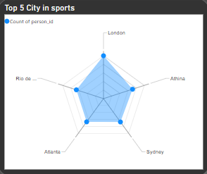

**CONCLUSION**

**These 5 cities have the highest no of participants in Olympics. They won most medals in the Olympics.**

**Season Analysis**

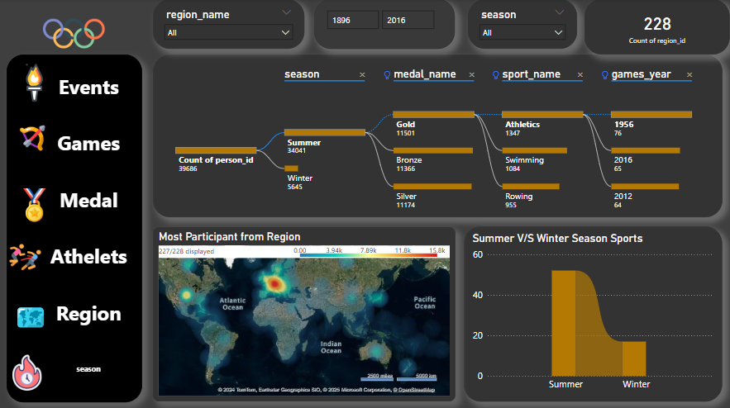

**How many Olympic Games have been held in each season (Summer vs. Winter)?**

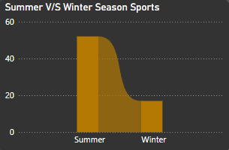

**CONCLUSION**

**-Total Summer Olympic Games is 52 from 1896 to 2016.**

**--Total Winter Olympic Games is 17 from 1896 to 2016.**

**Which regions have the highest number of participants in the Olympics?**

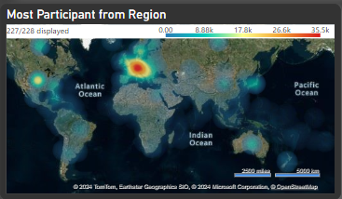

**CONCLUSION**

**These are top 5 Region whose participation is highest among all the region:**

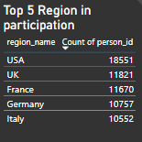

**How many Olympic Games have been held in each season (Summer vs. Winter)?**

**OVERALL DISTRIBUTION**

**It shows overall distribution of the season, medals, sports and game years.**

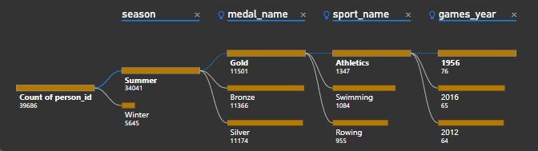

| **1. How many Olympic Games have been held in each season (Summer vs. Winter)?** |
| --- |
| **2. What is the distribution of games across different decades?** |
| **3. Which cities have hosted the most Olympic Games?** |
| **4. What is the distribution of sports between Summer and Winter Olympics?** |
| **5. Which sports have the highest number of events in the Olympics?** |
| **6. How has the participation in each sport evolved over time?** |
| **7. How many events are there in each sport?** |
| **8. What is the distribution of events by gender (Men, Women, Mixed)?** |
| **9. How has the number of events changed over time?** |
| **10. What is the distribution of participants by gender?** |
| **11. Which countries have the highest number of participants in the Olympics?** |
| **12. How does the age distribution of participants vary across different games?** |
| **13. How many medals have been awarded in each Olympics?** |
| **14. Which countries have the highest number of gold medals?** |
| **15. How does the medal distribution vary across different sports?** |
| **16. How many regions or NOCs participate in each Olympic Games?** |
| **17. Which regions have the highest number of participants in the Olympics?** |

**Power Bi Problem Statement**

**EDA**

**Problem Statement**

**SPORTS DASHBOARD**

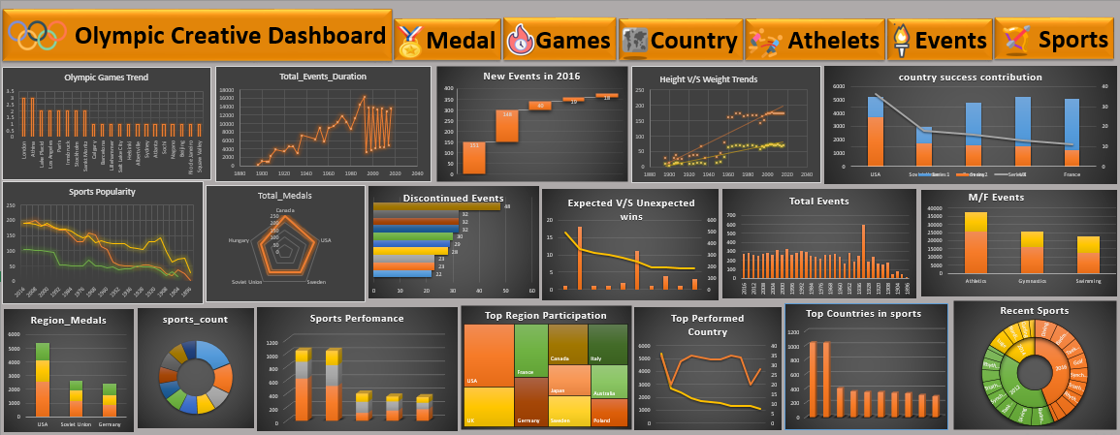

**EXCEL**

**PROBLEM STATEMENT**

1. **Are there any trends or patterns in the frequency of hosting Olympic Games?**

**CONCLUSION**

**London and Athina hosted Olympic games 3 times which is higher than other countries.**

**2. How has the duration of Olympic Games changed over time?**

**CONCLUSION**

**Olympic games duration has changed with the time because duration of starting years it was less but with years it's also increased.**

1. **Are there any notable events or occurrences associated with specific Olympic Games?**

**CONCLUSION**

**Notable event is 1932 year of Olympic. Because it has the highest no event**

1. **Are there any emerging sports that have been recently added to the Olympics?**

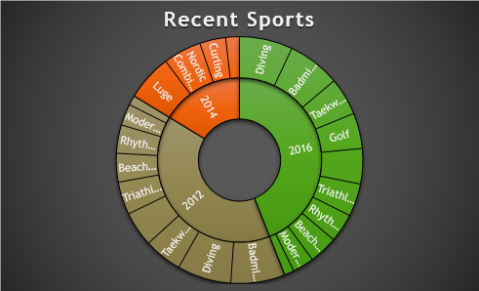

**CONCLUSION**

**These are some recent sports which have added after 2010 year of Olympic edition**

1. **How has the popularity of certain sports changed over the years?**

**CONCLUSION**

**Swimming and athlete popularity have increased with years faster than football.**

**6. Are there any sports that are specific to a particular region or culture?**

**CONCLUSION**

**USA, UK and France has the highest no of sports played which is Athletics.**

**Are there any sports that have a higher number of events for one gender compared to others?**

**CONCLUSION**

**Male events have high no events, but female events is too less. It can be because of participation.**

**8. Are there any new events that have been introduced in recent editions of the Olympics?**

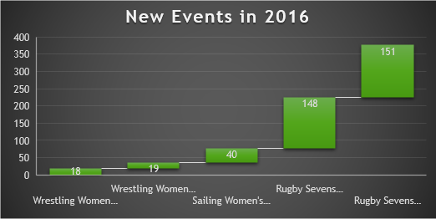

**CONCLUSION**

**These are some new events which has introduced in the olympic new edition.**

**Are there any events that have been discontinued or removed from the Olympics?**

**CONCLUSION**

**These are some new events which has removed from the Olympic new edition.**

**10. Are there any notable trends in the height and weight of participants over time?**

**CONCLUSION**

**Over the Years, the demand of healthy and physically fit athletes has significantly increased for well-performance criteria**

**11. Are there any dominant countries or regions in specific sports or events?**

**CONCLUSION**

**These are dominant country because they won most medals in particular events.**

**12. What factors contribute to the success or performance of participants from different countries?**

**CONCLUSION**

**Country participation can be tell on bases of their medals, participation and Athletes participation so these country are on top.**

**13. Are there any countries that consistently perform well in multiple Olympic editions?**

**CONCLUSION**

**These countries have performed well in Olympics because their appearance and their medals no both very high.**

**14. Are there any sports or events that have a higher number of medalists from a specific region?**

**CONCLUSION**

**These are 5 top events where athletes achieved highest no of medals.**

**15. What are some notable instances of unexpected or surprising medal wins?**

**CONCLUSION**

**These are Top 10 instances where we can see surprising medal wins.**

**16. Are there any regions that have experienced significant growth or decline in Olympic participation?**

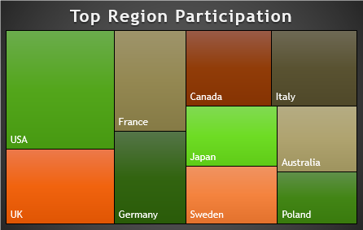

**CONCLUSION**

**These are top 10 country where participation is increased.**

**17. How do cultural or geographical factors influence the performance of regions in specific sports?**

**CONCLUSION**

**These are top sports which won most medals in Olympic.**

**18. Are there any regions that have had a notable impact on the overall medal tally?**

**CONCLUSION**

| **These are the Top 3 Regions who have impacted the overall medals totally** |
| --- |
| 1.**USA** |
| 2.**Soviet Union** |
| 3.**Germany** |
| **Because they Got the highest medals in overall Olympic games.** |

**Conclusion**  
The analysis of Olympic sports highlights the dynamic evolution of the games, reflecting shifts in global participation, performance trends, and the inclusion of diverse events. Historical data reveals a steady rise in athlete representation, gender equity advancements, and competitive parity across nations. Performance trends demonstrate the impact of technological innovations, training methodologies, and investment in sports infrastructure on medal tallies. Furthermore, the growing inclusion of non-traditional sports underscores the Olympics' adaptability to cultural and generational preferences, ensuring relevance in the modern era.

By leveraging these insights, stakeholders can better understand the factors contributing to athletic success, enabling informed decisions to promote inclusivity, sustainability, and excellence in future Olympic Games.